**PRODUCTS REQUIREMENT DOCUMENT FOR SHOPCRUSH ECOMMERCE**

COMPONENTS

1. OBJECTIVES
2. RELEASE
3. FEATURES
4. USER FLOW AND DESIGN
5. ANALYTICS
6. FUTURE WORK
7. **OBJECTIVES**

Vision: Shop Crush is a product that will change the way people shop online. Shop Crush will be a foremost shopping platform for intuitive, easy, fast, suggestive and AI (Artificial Intelligence) assistant shopping platform.

Goals:

* To be a foremost shopping platform that understands and implements shopper persona and interests.
* To create a specialized and customized shopping experience tailored for and to the shoppers taste.
* To increase shopping time and aid shopping interest
* To redesign online shopping system from the regular brick and mortar old mall shopping experience translated online.
* By assisting shoppers save more time in shopping and yet increasing cart value and purchasing probability on every visit.
* By helping translate more businesses to e-shopping from old mortar and brick stores.
* Allowing compatibility and integration with AI and VR for the purpose of insightful, suggestive, intuitive and connection between products and shoppers.
* Allowing collaborative shopping by creating real time connections on shopping platforms.
* Allowing notice and real time reminders of pending actions, purchases, upgrades, stock alert, new arrivals and promotions on priority / favorite products.

PERSONAS:

* + - The typical user of this products are online shoppers
    - Family groups willing to experience the brick and mortar family shopping feel even when distant from each other.
    - The busy scheduled individuals wanting to shop quick and fast.
    - The shoppers who mostly are bounce off e-commerce platforms due to cumbersome product categories and lists.
    - Shoppers in their teens.
    - Parents and Grandparents who still want keep the tradition of family shopping.

1. **RELEASE**

RELEASE: SHOP CRUSH VERSION 1.0

DATE: DUE 5TH MARCH, 2020.

INITIATIVES:

FEATURES:

* Persona creation features
* Filter Menus
* Aggregated Menu types includes - Colors - Favorites - Interests.
* Distraction Free Checkouts
* Shopping Carts Sharing
* Shopping Wish-list | Favorites Sharing
* Group | Family Shopping
* Shopping Dashboard
* Persona based shopping experience
* Get Instant Help Panel

MILESTONES:

DEPENDENCIES:

1. **FEATURE**

|  |  |  |  |  |  |  |  |  |
| --- | --- | --- | --- | --- | --- | --- | --- | --- |
| SN | FEATURE | DESCRIPTION | PURPOSE | USER PROBLEM | USER VALUE | ASSUMPTIONS | NOT DOING | ACCEPTANCE CRITERIA |
| 1 | PERSONA  CREATION FEATURE | User creates a shopping persona through interest selection. |  |  |  |  |  |  |
| 2 | FILTER MENU | Menu based on product category filters. |  |  |  |  |  |  |
| 3 | AGGREGATED MENU TYPES | 3-5 Menu list on the menu bar. |  |  |  |  |  |  |
| 4 | DISTRACTION FREE CHECKOUTS | Checkouts for users without sidebars, footers and menu bar. | Causes the user to be focused on the simple task of complete |  |  |  |  |  |
| 5 | SHOPPING CART SHARING | Users can share their shopping list, shopping wishlist, shopping cart with friends and family. |  |  |  |  |  |  |
| 6 | SHOPPING WISH LIST | Users collections of favorite products or future intended purchases. |  |  |  |  |  |  |
| 7 | GROUP | FAMILY SHOPPING | Cart sharing that allow users to interact with friends and family while shopping real time. |  |  |  |  |  |  |
| 8 | GET INSTANT HELP PANEL | Users can get access to care agents, FAQs, Guides on usage or problems encountered |  |  |  |  |  |  |

1. **USER FLOW DESIGN**

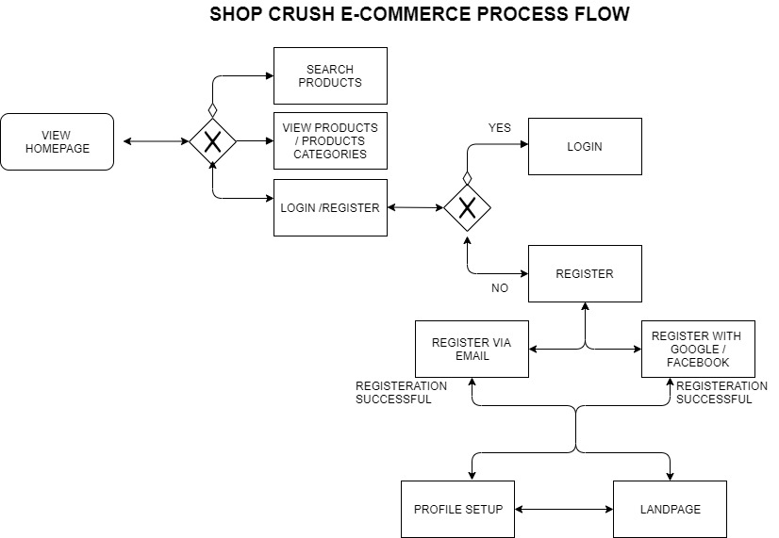

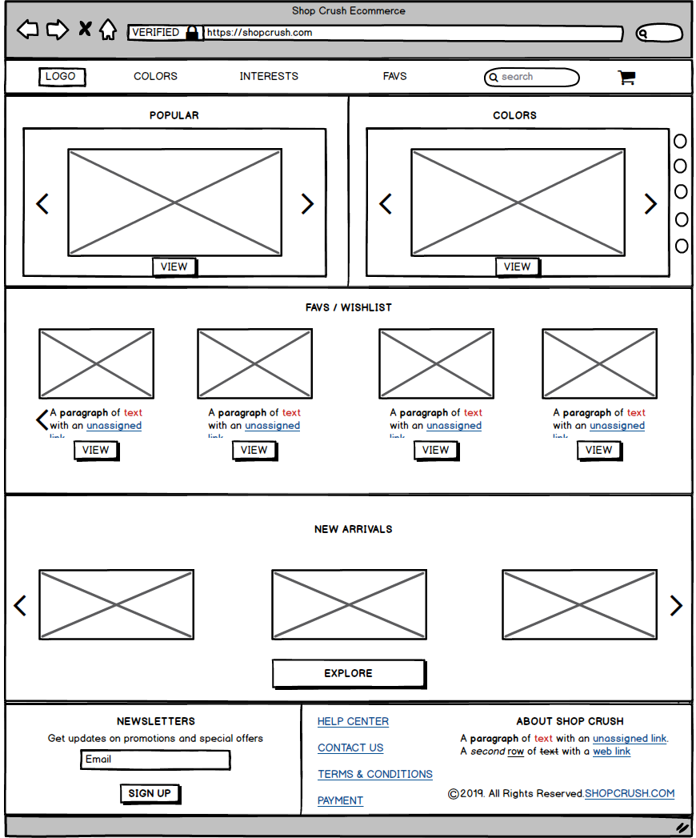

1. **ANALYTICS**
2. **FUTURE WORK / UPGRADES**